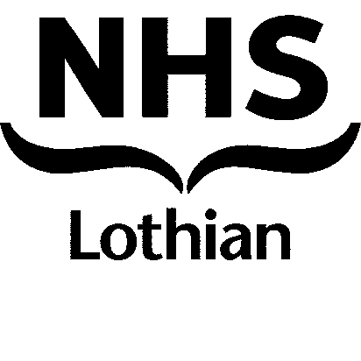

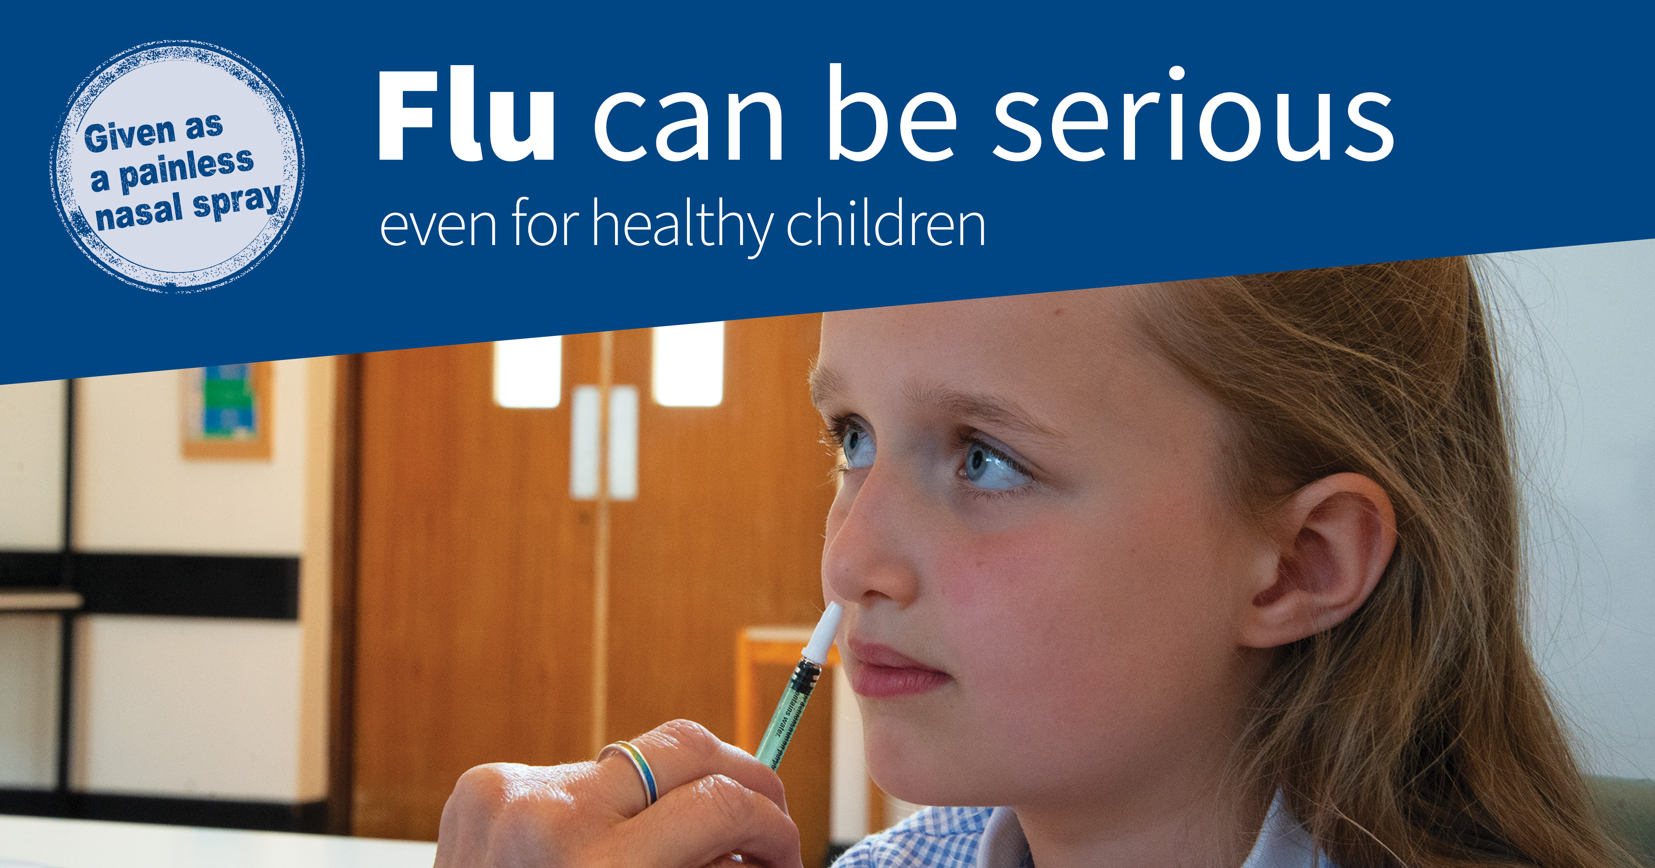

**NHS Lothian School Flu Vaccination Programme 2021/2022 Frequently Asked Questions (FAQs) for Parents / Carers of Primary or Secondary Pupils**

**What are the major changes in the school flu vaccination programme for 2021/2022?**

* All secondary pupils are now eligible (along with all primary pupils as in previous years)
* The flu vaccine injection is now available in school sessions for the small number of children who are unable to receive the nasal flu vaccine because of clinical or religious reasons.

# When do I need to return my consent form by and why is it important?

It is important that you return your child’s completed and signed consent form as soon as possible. The form is your formal response that you have made an informed decision to have/or not have your child immunised against flu. The consent form gives information so the NHS team can decide whether your child can receive the flu vaccine in school.

If you do not return your completed consent form within the timescale, your child may not be immunised. **Please take care to ensure that the consent form is completed in full, answering all the questions** and remember to both tick **and** sign the consent section of the form and provide a day time telephone number where you can be contacted by the NHS team if needed.

# I am unsure about how to complete the consent form. What can I do?

Schools will have a copy of guidance to help with completing the consent form. If you are still having difficulty with any of the questions, please contact the Community Vaccination Team on **0131 446 4082.** Your child will not be given a flu vaccine if the form is incomplete.

# I’ve lost my consent form / pack for flu vaccination for my child or I can’t remember if I have returned it. What can I do?

Please contact your child’s school to ask for a replacement – please note that this will be a blank form so **all** of your child’s details will need to be completed.

# When will my child get the vaccine and how do I know when my child’s school is scheduled to have the vaccination session?

Most children will be immunised in late September, October, November or December. The sessions will take place in school and schools will know the session date so you can ask there. Sessions for those who missed the school session will be arranged by the Community Vaccination Team. They can be contacted by telephone on: **0131 446 4082**

# I completed the consent form for my child to have the flu vaccination but I have changed my mind and no longer wish my child to have the vaccination. What should I do?

Please telephone the Community Vaccination Team on **0131 446 4082** and **also** confirm that you are withdrawing your consent in writing to the Health Board at the address in the letter which came with the consent form pack. Please do not hand notes to the school office. Withdrawal **must** be communicated to the Community Vaccination Team both by telephone **and** in writing one week before the vaccination session. If there are exceptional circumstances and you have to withdraw on the day, please ensure that you inform the school office.

# Are there any clinical reasons why my child shouldn’t have the nasal (nose) spray vaccine?

Most children are able to have the nasal (nose) spray form of the vaccine. For further details, please refer to the Public Health Scotland [information leaflet](https://publichealthscotland.scot/media/8716/web_parent-leaflet_0332.pdf) .

Please ensure all medications your child takes are written on the consent form.

# If your child has asthma and it is worse than usual (with more wheezing or increased use of oral steroid or inhalers 3 days before immunisation) this should be reported to the Community Vaccination Team on 0131 446 4082. The team will advise you as your child may not be able to receive their flu vaccine.

**My child has a medical condition and previously would have attended the GP Practice for flu vaccination early in the season. Can I still arrange this at my GP Practice?**

If a school vaccination session is **late** in the season, a parent who has a child with a **medical condition** may arrange for earlier vaccination. Please phone the Community Vaccination Team on **0131 446 4082** to make an appointment.

# Does my child only need one vaccination?

In **most** cases **only one vaccination is needed** every year in primary school. Please see the Public Health Scotland flu vaccination [information leaflet](https://publichealthscotland.scot/media/8716/web_parent-leaflet_0332.pdf) for further detail.

Please see the Public Health Scotland [information leaflet](https://publichealthscotland.scot/media/8716/web_parent-leaflet_0332.pdf) for the answers to other questions you may have about the flu vaccine. If you need further information, please contact the Community Vaccination Team on **0131 446 4082** or see the web site below:

[www.nhsinform.scot/childflu](http://www.nhsinform.scot/childflu)

The information leaflet may be made available in a larger print, Braille or your community language. Please see NHS inform for [alternative languages](https://www.nhsinform.scot/flu-vaccine/leaflets-other-languages-and-accessible-formats/other-languages), [British sign language](https://www.nhsinform.scot/flu-vaccine/leaflets-other-languages-and-accessible-formats/british-sign-language-bsl-child-flu-vaccine), and [audio format.](https://www.nhsinform.scot/translations/formats/audio/flu-vaccine-audio)