St. Joseph’s Primary School

Linlithgow

Positive Behaviour

and

Relationships Policy

Updated: January 2019
St. Joseph’s PS, Linlithgow

At St. Joseph’s PS, we celebrate our identity as a small Roman Catholic school in Linlithgow with an ethos underpinned by Christian values. This policy is also supported by the principles of Getting it Right for Every Child (GIRFEC) and reflects the importance of children’s rights as set out in the United Nations Convention of the Rights of the Child (UNCRC). We believe that encouraging positive behaviour and building successful relationships will help our pupils to take increasing responsibility for their actions as developing young people and will help prepare them to become successful contributors to our future society.

We promote mutual respect by valuing each other and respecting the voices, beliefs and opinions of others. We believe in equality and fairness for all members of our school community. Children are at the heart of our school. We aim to provide all pupils with an education of the highest quality where the knowledge and skills acquired in Literacy, Numeracy and Health & Wellbeing allow creative enquiry to further enhance learning.

The aim of this policy is to create a school ethos where positive behaviour is praised and rewarded. Where the promotion of mutual respect, dignity and kindness is embedded at all levels and that this approach underpins the restorative manner in which incidents are resolved.

Rights Respecting Schools

In line with the UNCRC (Appendix 1), the pupils of St. Joseph’s RRS committee identified the following principles to be central to the development of our schools positive behaviour and relationships policy:

All children have rights.
Children have the right to learn in an environment free from disruption.
Everybody has the right to feel and be safe.
Everybody has the right to be respected and have their views listened to.

Reward Time
The UNCRC Rights of the Child Article 31 states that every child has the right to relax and play. At St. Joseph’s we recognise that pupils benefit from a set aside time each week to have the opportunity to play during break and lunchtime. We have also identified a 30 minute slot on a Friday where pupils can choose from a selection of activities that promote positive play experiences. During this time, teachers may also engage in reflective dialogue with groups of pupils to nurture positive peer relationships.

Class Charters
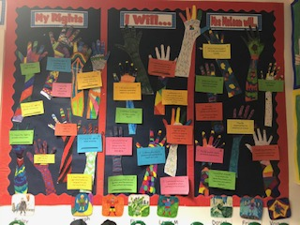
Class teachers negotiate Class Charters with their own class at the start of each session. The Charters link directly to the UNCRC and focus on the rights and responsibilities both of children and adults in the classroom. Each Charter forms the basis of a shared and understood set of expectations of behaviour for the class and helps to promote an effective learning and teaching environment. Class teachers link their Class Charter to the Whole school Charter.

Promoting a Nurturing Ethos

At St. Joseph’s we place our values at the centre of all that we do.
Our school values underpin our school ethos. This helps us to create a safe and
nurturing school community.

Kindness Love Honesty Respect

St. Joseph’s PS is developing a whole school nurturing approach which supports the provision of an inclusive learning environment and further underpins our positive behaviour and relationships policy. The 6 Nurture principles that we promote across the community of St. Joseph’s are:


- Children’s learning is understood developmentally.
- The classroom offers a safe base.
- The importance of nurture for the development of wellbeing.
- Language is a vital means of communication.
- All behaviour is communication.
- The importance of transition in children’s lives.

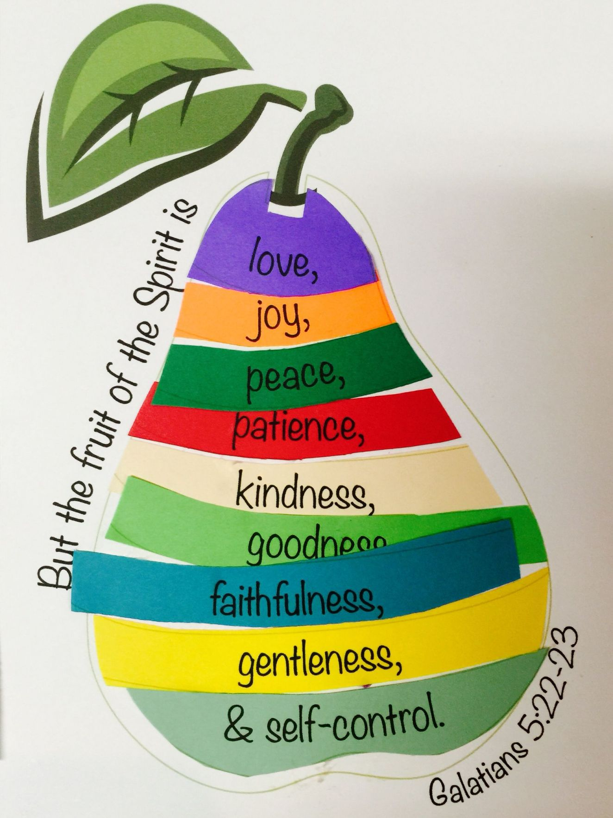
Rainbow Rewards

St. Joseph’s Rainbow Rewards scheme is a whole school approach to rewarding good behaviour and positive relationships. We encourage our pupils to behave in a way which reflects and promotes Gospel Values and the principles of Catholic Social Teaching (Appendix 2). We link our Rainbow Rewards to the Fruits of the Holy Spirit.

School House System

Each pupil at St. Joseph’s is allocated to be a member of a school house. Our school houses are organised by colour: Green, Red, Blue and Yellow. Each house is linked with a Scottish Saint: St. Kentigern, St. Margaret Queen of Scotland, St. Andrew and St. Michael. In school session 2017-2018 our pupils designed House Shields which display symbols related too school which are meaningful to the pupils of each house.

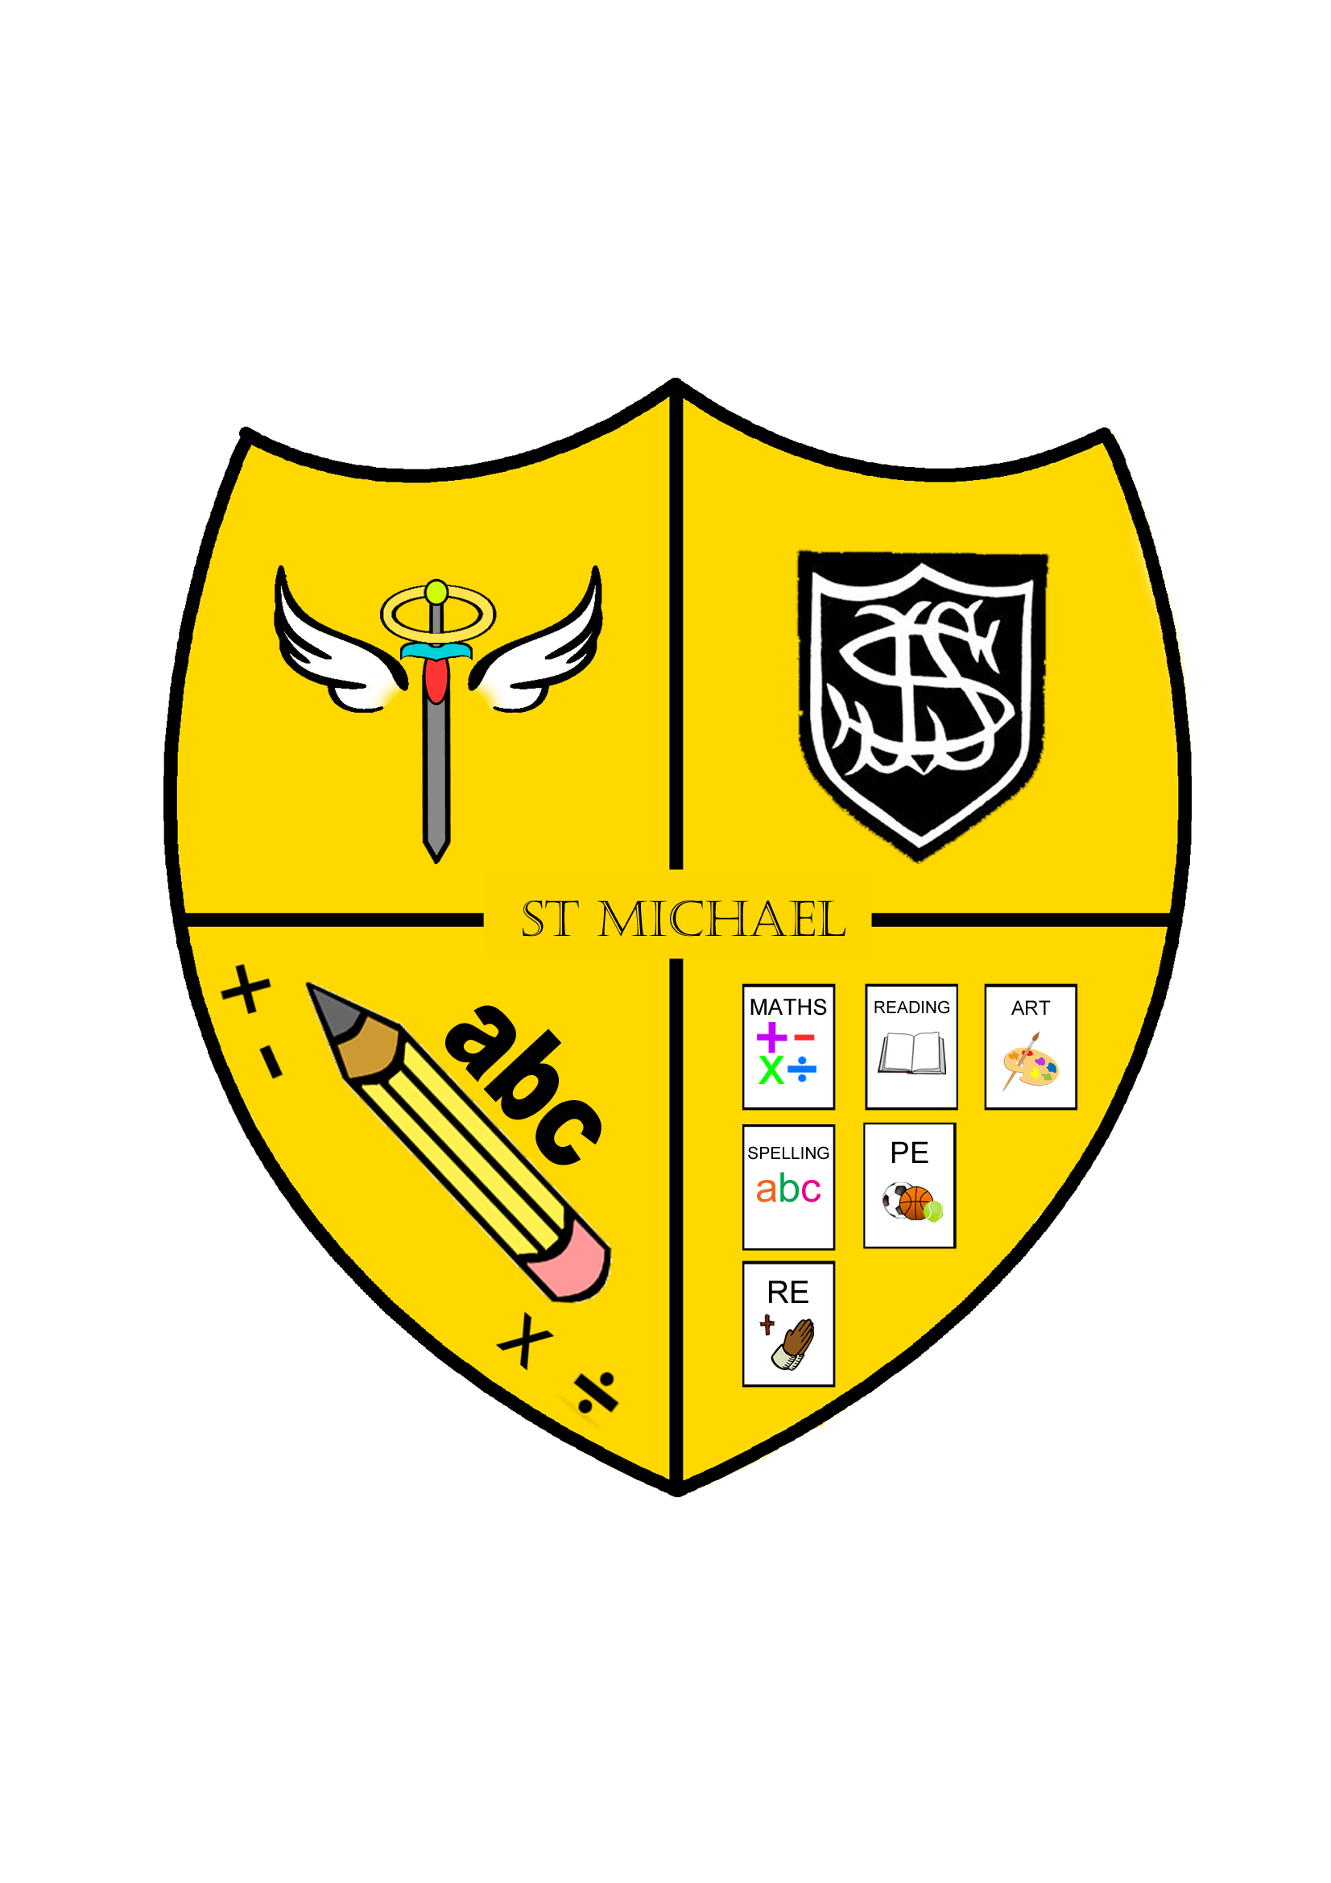
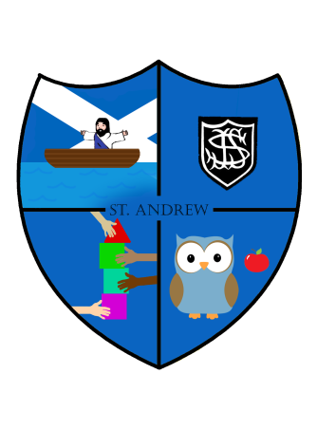
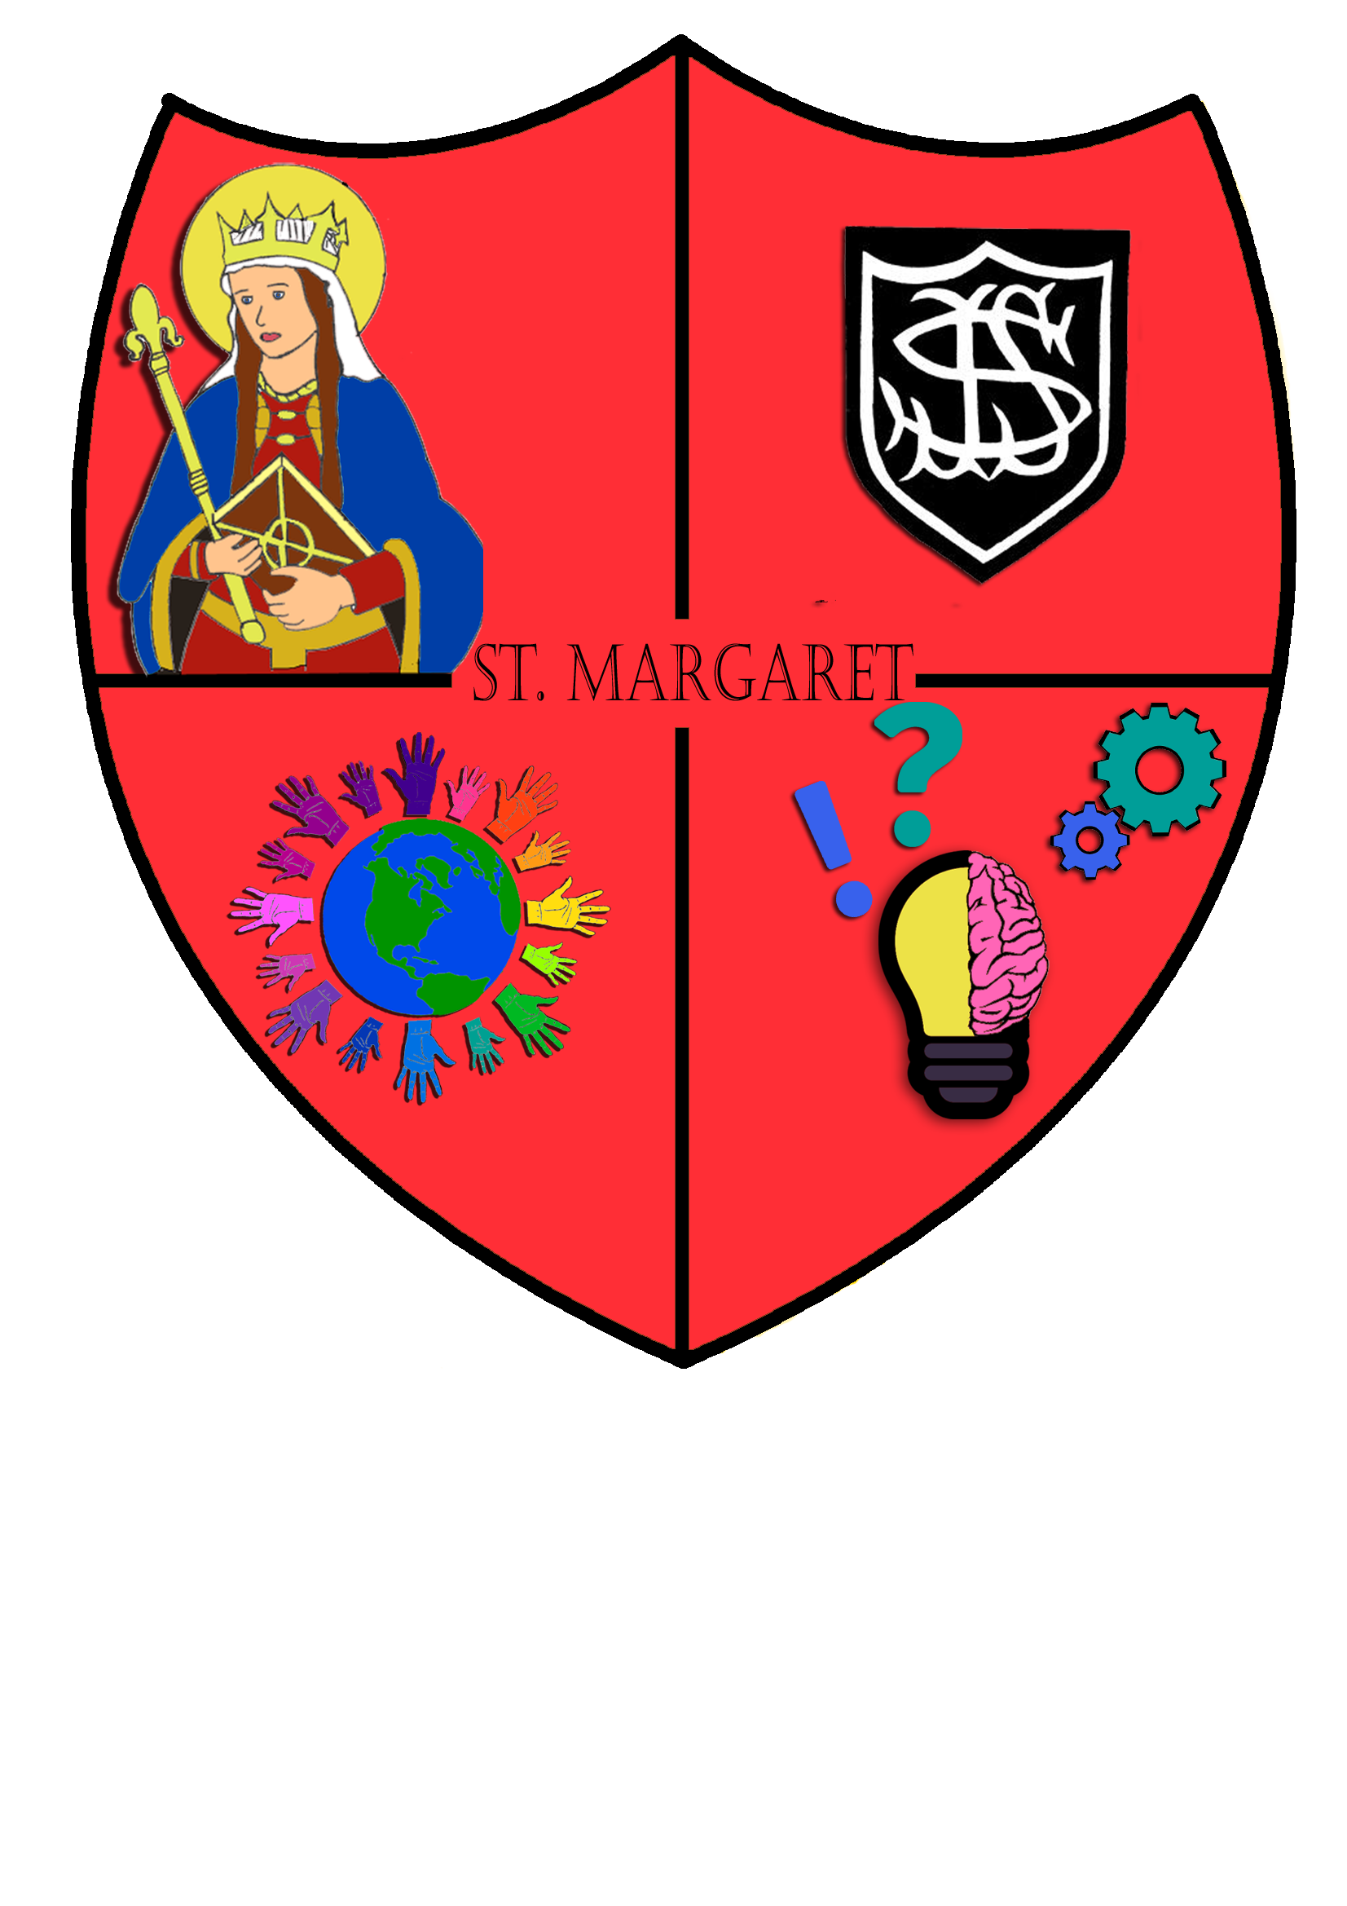
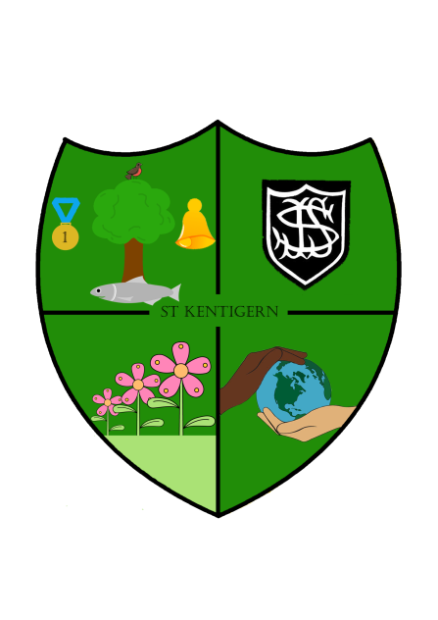

Each school house offers a pupil leadership opportunity in the form of a House Captain and Vice –Captain from Primary 7. They are responsible for encouraging their house members to collect stickers on their own individual sticker chart. Stickers are given from any adult in the school for good effort and behaviour. Each sticker represents 1 house point (See Appendix 3). Every point earned is turned into a token and collected on a weekly basis. The total for each house is announced and celebrated at our weekly whole school Assembly.

Each term there is a reward afternoon where every pupil in the school has the opportunity to take part in a whole school celebration of positive behaviour. The house with the most points collected receives a special recognition or reward for winning the termly challenge. At the end of the year the winning house is rewarded with the House Cup which is displayed in school for the remainder of the following school year, decorated with ribbons the colour of the overall winning house. The accolade of receiving the House Cup provides our pupils with an additional incentive to collectively ensure a high standard of good behaviour at St. Joseph’s across the school year.

We have high expectations of good behaviour at St. Joseph’s which relies on a shared understanding of our three central rules:

These rules are easy to remember and are used to address aspects of pupil behaviour which is deemed inappropriate. These rules generate a consistent approach across the school through the language used and through a shared understanding of expectations. At St. Joseph’s we believe that using restorative approaches in dealing with inappropriate behaviour is an effective way to ensure we foster mutual respect for all and that instances of unacceptable behaviour are dealt with in a timely and reflective manner.

There are times when pupils do not make good choices and their behaviour does not reflect expectations within these rules. It is important that pupils understand that when we make poor choices our behaviour can impact negatively on others. Time must be set aside for pupils to think and reflect on what they have done, take responsibility for their actions and look for positive ways to resolve any issues. The table below indicates the processes that are implemented at St. Joseph’s PS to resolve incidents of poor behaviour.

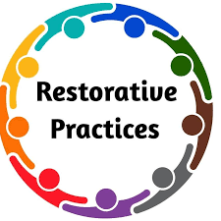
Verbal Reminders:
Explicit reminders of Ready, Respectful and Safe.
Pupil is given 3 opportunities to change their behaviour.

Reflection time:
Opportunity for time away from situation and reflection
(Pupils have access to a negotiated ‘Safe Space’ either within own classroom or allocated school area. Pupils also respond to short spells of time in a different classroom or quiet area of the playground/school)
Restorative discussion
(with CT/PT/HT and others involved when appropriate)

Phone call Home by Class Teacher/Principal Teacher/Head Teacher

Referral to School Senior Management Team

Arrangements based on Individual Circumstances

Referral to Partner Agencies for guidance and support

Referral to West Lothian Council Policy and Procedures

The escalation procedures indicated in the table are ordered in a way which demonstrates the level of intervention that may be required to resolve any issues. These sanctions are used across the school by all staff and extend to the playground. There are times when the interventions used are assessed on the nature of the issue meaning that certain sanctions could be used together or more serious sanctions used immediately, particularly when there has been physical harm.

Depending on the circumstances, we may decide to apply further or different kinds of sanctions which may be more appropriate for individual children to respond to. There can be situations which present persistent challenging behaviour. We devise ways to tailor interventions which are appropriately matched to the needs of particular pupils. This may include an individual positive behaviour contract with agreed loss of privileges and individual incentives for reward.

Positive Recognition Boards

In session 2018-2019 St. Joseph’s PS introduced positive recognition boards in every classroom. Class teachers have the autonomy to design their board in their own chosen theme in collaboration with their pupils.

They are used to persistently and relentlessly develop positive ‘Learning Attitudes’ through catching pupils demonstrating the right kinds of behaviour towards their learning. Names go on the board to recognise learners demonstrating the desired learning attitude. In collaboration with the learners, class teachers will identify an aspect of pupil behaviour or learning that they wish to improve in their classroom. Both the teacher and pupils can nominate others to be put on the board. Once nominated, the pupils name is not removed from the board whilst the current ‘learning attitude’ is being worked on. Boards can be refreshed as often as is appropriate for the age and stage of each class. The key to this approach is to generate peer responsibility in getting all the names in the class on the board. Once this happens – the achievement should be celebrated.
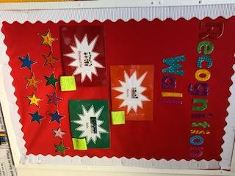

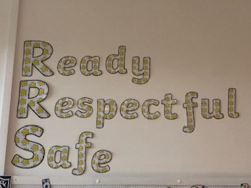

Extreme Behaviour and Anti-Bullying Procedures

Extreme behaviour will not be tolerated at St. Joseph’s PS and in very exceptional circumstances a child may be excluded from school. A parental meeting is required when this happens, to guarantee that an improvement will be made in their child’s behaviour.

St. Joseph’s PS promotes a culture where bullying behaviour is not acceptable. Our school community is committed to establishing a caring, learning environment where all members are valued and everyone has a responsibility to promote respect, openness, honesty and understanding. The inclusive ethos and culture of positive behaviour that we aim to achieve at St. Joseph’s is consistent with the desired outcomes of local authority guidance. Specific individual consequences for extreme and bullying behaviour may be implemented in accordance with the ‘Promoting Positive Relationships in West Lothian Educational Establishments’ Policy. Please access the link below to access this policy:

https://www.westlothian.gov.uk/media/2141/Exclusion-Policy/pdf/Promoting_Positive_Relationships_in_West_Lothian_Educational_Establishments.pdf

Respect For All

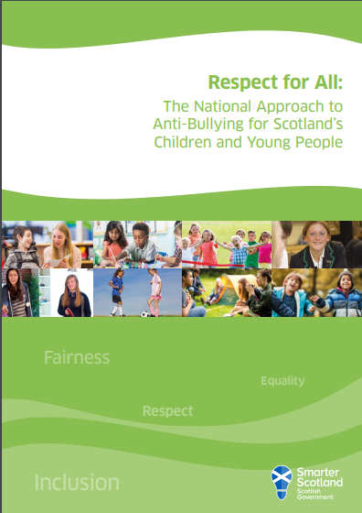
The review of the St. Joseph’s positive relationships and behaviour policy was also shaped by the Scottish Governments latest guidance on Anti-Bullying. The ‘Respect for All: National Approach to Anti-Bullying’ policy recognises the impact that bullying can have on pupil wellbeing and highlights that in order for young people to thrive and achieve their full potential they need to learn in environments which are safe, nurturing, respectful and free from fear, abuse and discrimination. St. Joseph’s seeks to mirror that Scottish Governments view that this can be achieved through embedding positive relationships and behaviour approaches in our school. You can find out more about this Scottish Government policy at the link below:

https://www.gov.scot/publications/respect-national-approach-anti-bullying-scotlands-children-young-people/

Parent Partnerships

Parents will be encouraged to work in partnership with the school to ensure that this policy is effective. Parents should encourage their children to be respectful towards the values and opinions of others and show respect towards everyone within the school community. They should support the school in the implementation of this policy in recognition that positive behaviour and relationships underpin the effectiveness of the learning and the quality of pupil experiences at St. Josephs.

Appendix 1

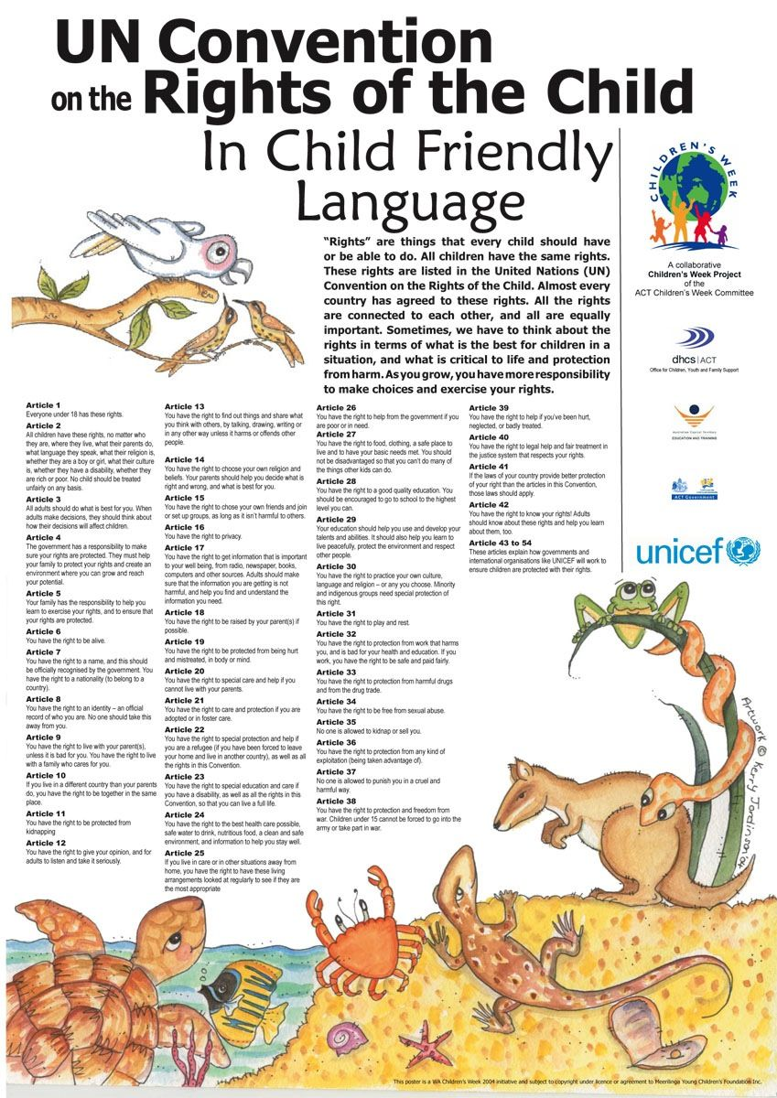

Appendix 2
The Principles of Catholic Social Teaching


St. Joseph’s PS promotes Gospel Values as part of the Catholic Ethos being developed across the school community. Each classroom has a sacred space where the Holy Bible and other religious artifacts and prayers are displayed. The poster below is also displayed in all classrooms to help our pupils understanding of the principles integral to Catholic Social Teaching which underpin our values.

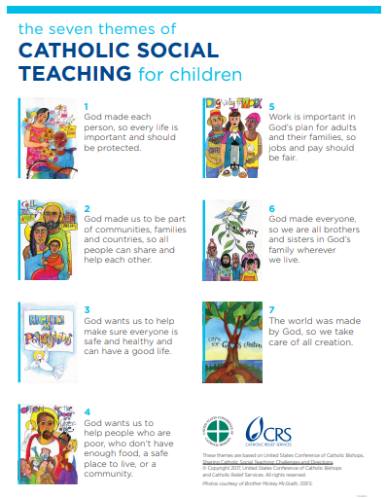

Appendix 3
Rainbow Rewards

s

At Saint Joseph’s Primary school, we expect excellent behavior at all times.

All pupils in this school are assigned a ‘House Colour’ and a ‘Rainbow Rewards’ card.


Our houses at Saint Joseph’s are-

The Yellow House

The Red House

The Green House

The Blue House

Each house has a ‘House Captain’ their role is to promote positive behaviour and encourage their house to gain as many reward points as possible.

We praise and reward positive behavior by:

Giving praise in the classroom for positive behavior

Awarding stars, stickers and smiley faces for pupils to attach to their house rainbow reward cards

Awarding Class Teacher, Principal Teacher, and Head Teacher certificates.

Awarding Silver and Gold Awards

Providing a whole school reward afternoon at the end of every term

Number Of Stickers | Award
10 Stickers | Class Teacher Award
20 Stickers | Principal Teacher Award
30 Stickers | Head Teacher Award
40 Stickers | Silver Award
50 Stickers | Gold Award

